**COVID-19 CASES ANALYSIS**

**Chapter_1**

**Abstract**

Corona Virus Disease- 19 (COVID-19) was first time reported in Wuhan, China. This disease has covered more than 200 countries till May 2020. World Health Organisation (WHO) has declared COVID-19 as Public Health Emergency of International Concern (PHEIC) on 30 January 2020. COVID- 19 causes severe acute respiratory syndrome coronavirus 2 (SARS-CoV-2) which was progressive earlier in China but now in maximum countries. Therefore, the different online platform are used which provides the latest update of confirmed corona cases throughout the globe for the analysis of data. The aim of data analysis for CIVID-19 is to aware of the community against the infectious disease and forecast the COVID-19 confirmed cases, deaths, and recoveries through the data analysis methods. Different models are also used to study the behavior of the disease. The models help to forecast the patterns of public sentiments on health information with both the political and economical influence of the spread of the virus. Data analysis methods which are used are Exploratory Data Analysis (EDA) in which the number of confirmed cases, death, and recovered data are recorded, model like Susceptible-Exposed-Infectious-Recovered (SEIR) model is used to predict the time and the rate taken for the spreading up of disease throughout the globe. A statistical model can also be used to compare the data among different countries to make humans aware of the infection.

Keywords: 2019-nCoV, SARS-CoV-2, Coronavirus, COVID-19

**Chapter_2**

**INTRODUCTION**

The outbreak of the new disease in Wuhan, China was caused by novel Coronavirus (2019-nCoV) [1]. This disease is a form of pneumonia. Coronavirus belongs to the Orthocoronavirinae subfamily. The first case was observed at the Chinese Center for Disease Control and Prevention (CDC) on 12 December 2019 and was considered as a nonSARS novel coronavirus [2]. The family to which Coronavirus belongs is Coronaviridae which consists of a large, single RNA strand of plus sign [3]. Viruses of these family show the symptoms of common cold, diarrhea in human beings. In the year 2003, it was seen the outbreak of coronavirus i.e. severe acute respiratory syndrome coronavirus (SARS-CoV) [4]. In December 2019 at Wuhan, China's symptoms closely resembled the same as pneumonia [5]. Several cases of approximately 1974 were confirmed in China according to the council information office in Beijing, China's capital on 26th January, 2020. Virus started spreading in many other countries like the very first case after China was reported in Thailand, Japan and two cases were also seen in Korea on 16 January 2020. Recent researches have shown some evidence of the origin of the virus from the bat and it was also seen that transmission of the virus is taking place from human to human. The situation started getting worst from 19 January 2020 day by day,

The **COVID-19 pandemic in India** is a part of the [worldwide pandemic](https://en.wikipedia.org/wiki/COVID-19_pandemic) of [coronavirus disease 2019](https://en.wikipedia.org/wiki/COVID-19) (COVID-19) caused by [severe acute respiratory syndrome coronavirus 2](https://en.wikipedia.org/wiki/Severe_acute_respiratory_syndrome_coronavirus_2) (SARS-CoV-2). As of 25 September 2023, according to Indian government figures, India has the second-highest number of confirmed cases in the world (after the [United States of America](https://en.wikipedia.org/wiki/COVID-19_pandemic_in_the_United_States)) with 44,998,162[[4]](https://en.wikipedia.org/wiki/COVID-19_pandemic_in_India#cite_note-Template:COVID-19_data-4) reported cases of COVID-19 infection and the third-highest number of COVID-19 deaths (after the United States and [Brazil](https://en.wikipedia.org/wiki/COVID-19_pandemic_in_Brazil)) at 532,030[[4]](https://en.wikipedia.org/wiki/COVID-19_pandemic_in_India#cite_note-Template:COVID-19_data-4) deaths.[[6]](https://en.wikipedia.org/wiki/COVID-19_pandemic_in_India#cite_note-BBCNews-2021-1-6)[[7]](https://en.wikipedia.org/wiki/COVID-19_pandemic_in_India#cite_note-7) In October 2021, the [World Health Organization](https://en.wikipedia.org/wiki/World_Health_Organization) estimated 4.7 million excess deaths, both directly and indirectly related to COVID-19 to have taken place in India.[[8]](https://en.wikipedia.org/wiki/COVID-19_pandemic_in_India#cite_note-Biswas-8)[[9]](https://en.wikipedia.org/wiki/COVID-19_pandemic_in_India#cite_note-WHO_estimate-9)

The first cases of COVID-19 in India were reported on 30 January 2020 in three towns of [Kerala](https://en.wikipedia.org/wiki/Kerala), among three Indian medical students who had returned from [Wuhan](https://en.wikipedia.org/wiki/Wuhan), the epicenter of the pandemic.[[10]](https://en.wikipedia.org/wiki/COVID-19_pandemic_in_India#cite_note-Andrews-2020-10)[[11]](https://en.wikipedia.org/wiki/COVID-19_pandemic_in_India#cite_note-11)[[12]](https://en.wikipedia.org/wiki/COVID-19_pandemic_in_India#cite_note-12) Lockdowns were announced in Kerala on 23 March, and in the rest of the country on 25 March. Infection rates started to drop in September.[[13]](https://en.wikipedia.org/wiki/COVID-19_pandemic_in_India#cite_note-Infectiondrop-13) Daily cases peaked mid-September with over 90,000 cases reported per-day, dropping to below 15,000 in January 2021.[[14]](https://en.wikipedia.org/wiki/COVID-19_pandemic_in_India#cite_note-Safi-2021-14) A second wave beginning in March 2021 was much more devastating than the first, with shortages of vaccines, hospital beds, [oxygen cylinders](https://en.wikipedia.org/wiki/Gas_cylinder) and other medical supplies in parts of the country.[[14]](https://en.wikipedia.org/wiki/COVID-19_pandemic_in_India#cite_note-Safi-2021-14) By late April, India led the world in new and active cases. On 30 April 2021, it became the first country to report over 400,000 new cases in a 24-hour period.[[15]](https://en.wikipedia.org/wiki/COVID-19_pandemic_in_India#cite_note-15)[[6]](https://en.wikipedia.org/wiki/COVID-19_pandemic_in_India#cite_note-BBCNews-2021-1-6) Experts stated that the virus *may* reach an [endemic](https://en.wikipedia.org/wiki/Endemic_(epidemiology)) stage in India rather than completely disappear;[[16]](https://en.wikipedia.org/wiki/COVID-19_pandemic_in_India#cite_note-16) in late August 2021, [Soumya Swaminathan](https://en.wikipedia.org/wiki/Soumya_Swaminathan" \o "Soumya Swaminathan) said India may be in some stage of endemicity where the country learns to live with the virus.[[17]](https://en.wikipedia.org/wiki/COVID-19_pandemic_in_India#cite_note-Bhaduri-2021-17)

India began its [vaccination programme](https://en.wikipedia.org/wiki/COVID-19_vaccination_in_India) on 16 January 2021 with [AstraZeneca vaccine](https://en.wikipedia.org/wiki/Oxford%E2%80%93AstraZeneca_COVID-19_vaccine) (Covishield) and the indigenous [Covaxin](https://en.wikipedia.org/wiki/Covaxin" \o "Covaxin).[[18]](https://en.wikipedia.org/wiki/COVID-19_pandemic_in_India#cite_note-MyGov.in-2020-18)[[19]](https://en.wikipedia.org/wiki/COVID-19_pandemic_in_India#cite_note-19) Later, [Sputnik V](https://en.wikipedia.org/wiki/Sputnik_V_vaccine) and the [Moderna vaccine](https://en.wikipedia.org/wiki/Moderna_COVID-19_vaccine" \o "Moderna COVID-19 vaccine) was approved for emergency use too.[[20]](https://en.wikipedia.org/wiki/COVID-19_pandemic_in_India#cite_note-Livemint-20) On 30 January 2022, India announced that it administered about 1.7 billion doses of vaccines and more than 720 million people were fully vaccinated.[[21]](https://en.wikipedia.org/wiki/COVID-19_pandemic_in_India#cite_note-UNSDG-21)

**Chapter_3**

**PROBLEM** **STATEMENT**

A correlation study to assess the knowledge and self-expressed stigma regarding COVID-19 Outbreak among adults at selected society of Pune city. INTRODUCATION Coronaviruses are zoonotic. This means they first develop in animals before developing in humans. For the virus to pass from animal to humans, a person has to come into close contact with an animal that carries the infection. Once the virus develops in people, coronaviruses can be spread from person to person through respiratory droplets. This is a technical name for the wet stuff that moves through the air when you cough or sneeze. The viral material hangs out in these droplets and can be breathed into the respiratory tract (your windpipe and lungs), where the virus can then lead to an infection. 1 Coronavirus disease (COVID-19) is an infectious disease caused by a newly discovered coronavirus. The virus that causes COVID-19 is mainly transmitted through droplets generated when an infected person coughs, sneezes, or exhales. These droplets are too heavy to hang in the air, and quickly fall on floors or surfaces.

Common symptoms:

• Fever.

• Tiredness.

• Dry cough.

Some people may experience:

• Aches and pains.

• Nasal congestion.

• Runny nose.

• Sore throat.

• Diarrhoea

OBJECTIVES

1. To assess the knowledge regarding COVID-19 Outbreak among adults

2. study to assess self-expressed stigma regarding COVID-19 Outbreak among adults

3. To assess the correlation between knowledge and self-expressed stigma regarding COVID-19 Outbreak among adults

4. To associate the major findings of knowledge regarding COVID-19 Outbreak with selected demographic

5. To associate the major findings of self-expressed stigma regarding COVID-19 Outbreak with selected demographic

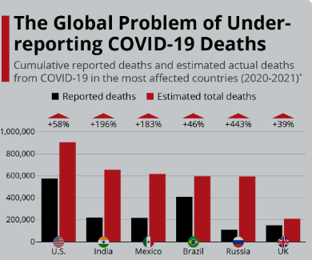

**Pandemic**

The World Health Organisation (WHO) has declared the coronavirus

disease 2019 (COVID-19) a pandemic [6] . A global coordinated effort is

needed to stop the further spread of the virus. A pandemic is defined as

“occurring over a wide geographic area and affecting an exceptionally high

proportion of the population.” [7]  The last pandemic reported in the world

was the H1N1 flu pandemic in 2009.

**What is Coronavirus?**

The number of people affected was exponentially growing and the World Health Organization (WHO) upgraded COVID-19 to a pandemic in March 2020. Pandemics are known to cause large-scale social disruption, economic loss, and general hardship, and COVID-19 has been no exception.

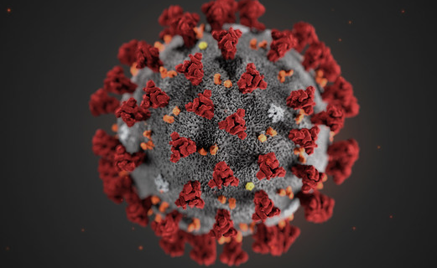

Coronaviruses are a family of viruses that cause illness such

as respiratory diseases or gastrointestinal diseases. Respiratory diseases

can range from the common cold to more severe diseases

**e,g.**

* Middle East Respiratory Syndrome (MERS-CoV)
* Severe Acute Respiratory Syndrome (SARS-CoV) [8] .

A novel coronavirus (nCoV) is a new strain that has not been identified in

humans previously. Once scientists determine exactly what coronavirus it

is, they give it a name (as in the case of COVID-19, the virus causing it is

SARS-CoV-2).

Coronaviruses got their name from the way that they look under a

microscope. The virus consists of a core of genetic material surrounded by

an envelope with protein spikes. This gives it the appearance of a crown.

The word Corona means “crown” in Latin.

Coronaviruses are zoonotic [9] , meaning that the viruses are transmitted

between animals and humans. It has been determined that MERS-CoV was

transmitted from dromedary camels to humans and SARS-CoV from civet

cats to humans [8] .  The source of the SARS-CoV-2 (COVID-19) is yet to be

determined, but investigations are ongoing to identify the zoonotic source

to the outbreak [10] .

**Clinical Presentation**

Typically Coronaviruses present with respiratory symptoms. Among those

who will become infected, some will show no symptoms. Those who do

develop symptoms may have a mild to moderate, but self-limiting disease

with symptoms similar to the seasonal flu [11] .

**Symptoms may include:**

* Respiratory symptoms
* Fever
* Cough
* Shortness of breath
* Breathing difficulties
* Fatigue
* Sore throat

A minority group of people will present with more severe symptoms and will need to be hospitalised, most often with pneumonia, and in someinstances, the illness can include ARDS, sepsis and septic shock .

Emergency warning signs where immediate medical attention should be sought

**include:**

* Difficulty breathing or shortness of breath
* Persistent pain or pressure in the chest
* New confusion or inability to arouse
* Bluish lips or face

**Preventing Transmission**

The WHO suggests the following basic preventative measures to protect

against the new coronavirus [18][19]

* Get vaccinated as soon as it’s your turn and follow local guidance on

vaccination.

* Keep physical distance of at least 1 metre from others, even if they
* don’t appear to be sick. Avoid crowds and close contact.
* Wear a properly fitted mask when physical distancing is not possible

and in poorly ventilated settings.

* Clean your hands frequently with alcohol-based hand rub or soap

and water.

* Cover your mouth and nose with a bent elbow or tissue when you
* cough or sneeze. Dispose of used tissues immediately and clean

hands regularly.

* If you develop symptoms or test positive for COVID-19, self-isolate

until you recover.

**Over view of covid-19**

Coronavirus disease (COVID-19) is an infectious disease caused by the SARS-CoV-2 virus. Most people infected with the virus will experience mild to moderate respiratory illness and recover without requiring special treatment. However, some will become seriously ill and require medical attention.

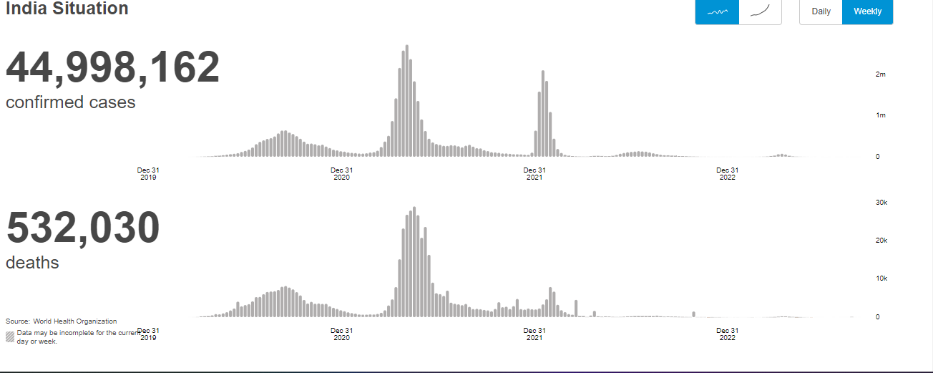

**Caese of covid-19**

Outside China, 794 cases were reported with three deaths6. We present here the first case of COVID-19 infection reported in Kerala, India. On January 27, 2020, a 20 yr old female presented to the Emergency Department in General Hospital, Thrissur, Kerala, with a one-day history of dry cough and sore throat.

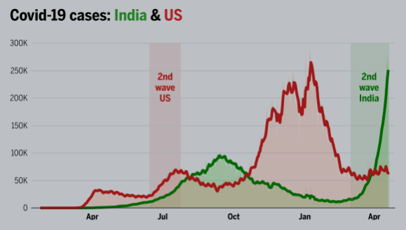

**Chapter_4**

**A Proposal to End the COVID-19 Pandemic**

Many countries have stepped up in the global fight against the pandemic, as have institutions such as the World Health Organization, the World Bank, Gavi (the Global Alliance for Vaccines and Immunization), the African Union, and others.Yet, more than a year into the COVID-19 crisis, new cases worldwide are higher than ever. Urgent action is needed to arrest the rising human toll and economic strain.

**Ending the pandemic is a solvable problem but requires further coordinated global action.**

As the IMF has warned, economic recoveries are diverging dangerously. The disparities will widen further between wealthy countries that have widespread access to vaccines, diagnostics, and therapeutics, and poorer countries still struggling to inoculate frontline healthcare workers. As of the end of April 2021, less than two percent of Africa’s population had been vaccinated. By contrast, over 40 percent of the population in the United States and over 20 percent in Europe had received at least one dose of the vaccine.

[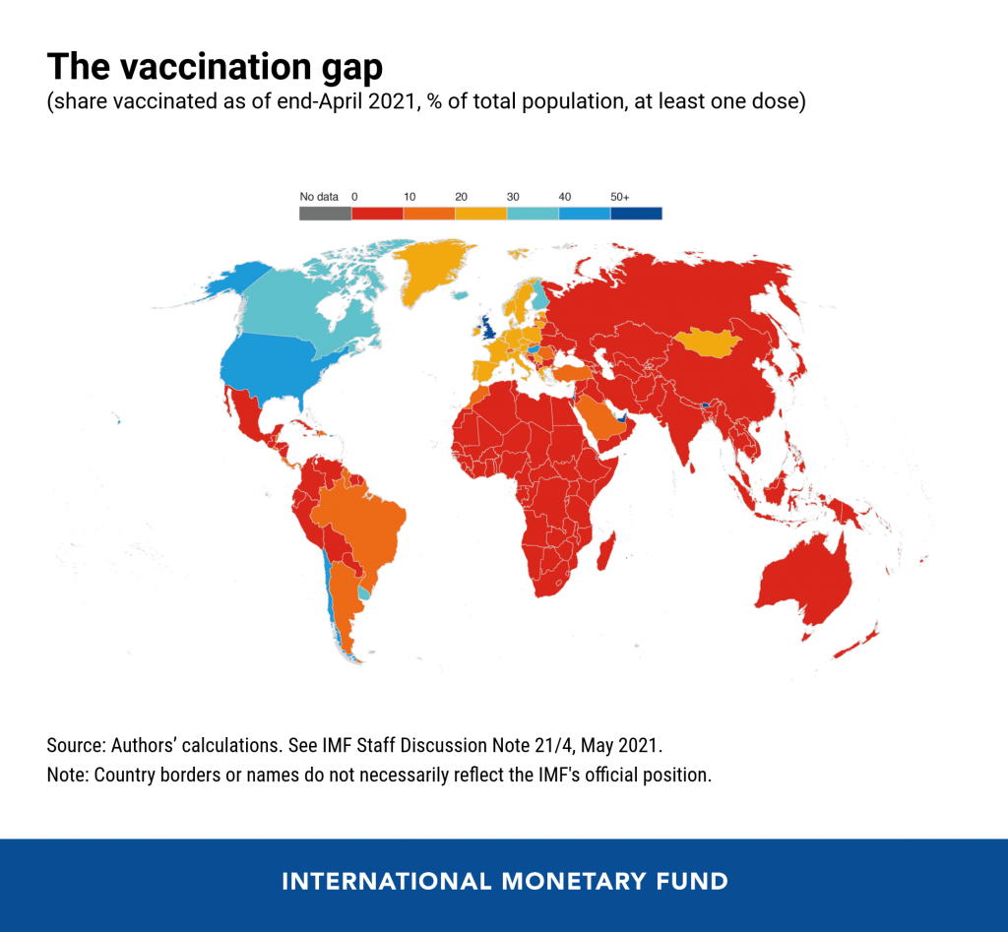](https://www.imf.org/wp-content/uploads/2021/05/pandemic-plan-chart-1-1024x947.png)

It is well understood that there can be no lasting end to the economic crisis without an end to the health crisis. Pandemic policy is thus economic policy. It is critical for global macroeconomic and financial stability, which makes it of fundamental importance to the IMF and other economic institutions. Ending the pandemic is a solvable problem but requires further coordinated global action.

The [latest research by IMF staff](https://www.imf.org/en/Publications/Staff-Discussion-Notes/Issues/2021/05/19/A-Proposal-to-End-the-COVID-19-Pandemic-460263)analyzes multiple dimensions of the fight against the pandemic and proposes realistic targets to bring the pandemic substantially under control everywhere—and the means to achieve them. Building on the work of other agencies, the proposal aims to:

* vaccinate at least 40 percent of the population in all countries by the end of 2021 and at least 60 percent by the first half of 2022,
* track and insure against downside risks, and
* ensure widespread testing and tracing, maintain adequate stocks of therapeutics, and enforce public health measures in places where vaccine coverage is low.

Importantly, the strategy requires not just commitments but **upfront** financing, **upfront** vaccine donations, and "**at-risk"** investment for the world to insure against downside scenarios.

The proposal’s total cost of around **$50 billion**would include grants, national government resources, and concessional financing.

There is a strong case for grant financing of at least **$35 billion**. The good news is G20 governments have already identified as important to address the $22 billion grant funding gap noted by the [Access to COVID-19 Tools (ACT) Accelerator](https://www.who.int/initiatives/act-accelerator). This leaves an estimated $13 billion in additional grant contributions needed.

The remainder of the overall financing plan—around **$15 billion**—could come from national governments, potentially supported by COVID-19 financing facilities created by multilateral development banks.

Saving lives and livelihoods should need no justification, but a faster end to the pandemic could also inject the equivalent of $9 trillion into the global economy by 2025 due to a faster resumption of economic activity. Advanced economies, likely to spend the most in this effort, would see the highest return on public investment inmodern history—capturing 40 percent of the cumulative $9 trillion in global GDP gains and roughly $1 trillion in additional tax revenues.

**Recommendations for action**

The key proposed steps include:

***Achieving the vaccination targets***

1. *Provide additional upfront grants to*[*COVAX*](https://www.who.int/initiatives/act-accelerator/covax)*of at least $4 billion*. This financing will help finalize orders and activate unused vaccine capacity.

2. *Ensure free cross-border flows of raw materials and finished* vaccines: Such restrictions are jeopardizing access to vaccines for billions of people in the developing world.

[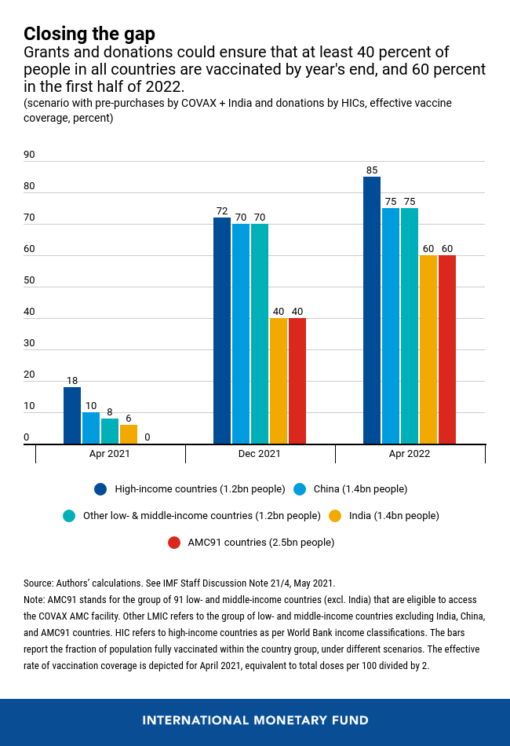](https://www.imf.org/wp-content/uploads/2021/05/Chart-2-pandemic-plan-chart-2.png)

We project the measures identified in steps 1–3 may be sufficient to achieve the 40 percent vaccination target by the end of 2021 and the 60 percent target by the first half of 2022, if no downside risks materialize.

***Insuring against downside risks***

4. *Make at-risk investments to diversify and increase vaccine production capacity by 1 billion doses*in early 2022 to handle downside risks in 91 low- and middle-income countries, including from new variants that may require booster shots. [$8 billion]

5. *Scale up genomic surveillance and systemic supply chain surveillance*with concrete contingency plans in place to handle possible mutations or shocks to the supply chain. These plans should be prepared with the participation of multilateral agencies, vaccine developers and manufacturers, and key national governments. [$3 billion]

***Managing the interim period when vaccine supply is limited***

6. Ensure widespread *testing, sufficient therapeutics, public health measures, and prepare for vaccine deployment*. [$30 billion]

7. Urgently evaluate and implement (where approved) *dose stretching strategies* to expand effective supply. [$2 billion]

Additional needed measures account for $3 billion. Steps 4–7 are needed to insure against downside risks, and to mitigate the health consequences of the pandemic in the interim period.

The proposal complements the work of the G20 High Level Independent Panel, the G7 Pandemic Preparedness Partnership group, and the Report of the Independent Panel for Pandemic Preparedness and Response, which primarily focus on addressing future pandemics. This proposal focuses on what is needed to bring the *current* pandemic under control. To make it effective, countries need to work together.

The world does not have to live through the pain of another record surge of COVID-19 cases. With strong global action now and with very little in terms of financing relative to the outsized benefits, we can durably exit this health crisis.

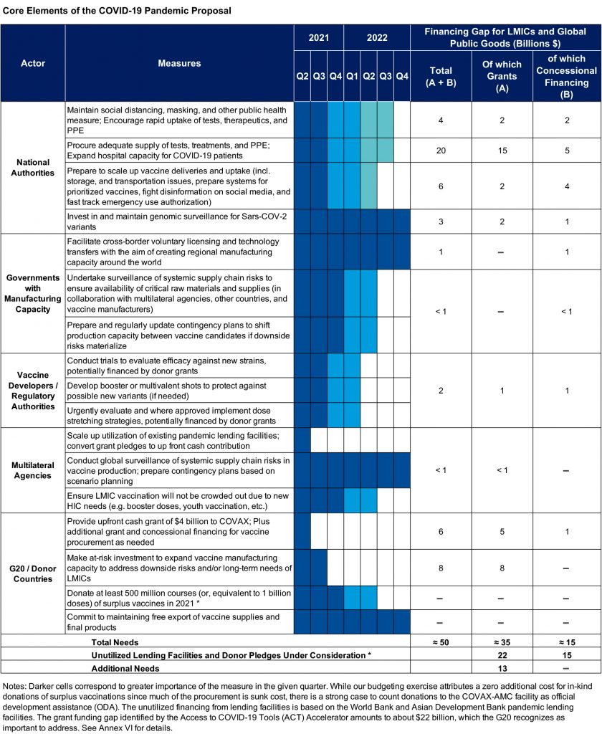

**Chapter_5**

**Exit in system in covid-19**

## Challenge

Scientists have known for some time that viruses enter and infect cells and then use the cell’s protein-making machinery to make multiple copies of themselves before escaping the cell. However, researchers have only a limited understanding of exactly how viruses exit cells.

## Advance

IRP researchers led by senior investigator [Nihal Altan-Bonnet, Ph.D.](https://irp.nih.gov/pi/nihal-altan-bonnet), discovered a biological pathway that SARS-CoV-2, the novel coronavirus responsible for the COVID-19 pandemic, uses to hijack and then exit cells as it spreads through the body. The research team showed for the first time that the novel coronavirus can exit infected cells through their lysosomes, a part of the cell commonly referred to as the cell’s 'trash compactor.' Normally, lysosomes destroy viruses and other pathogens before they leave cells. However, the team found that the coronavirus deactivates the lysosome’s disease-fighting machinery, allowing the virus to exit the cell after doing its damage and continue spreading freely throughout the body.

## Impact

A better understanding of this important pathway may provide vital insight into how to stop the transmission of COVID-19. In addition, targeting this lysosomal pathway could lead to the development of new, more effective antiviral therapies to fight the disease. Further studies will be needed to determine if such interventions will be effective and whether existing drugs can help block this pathway.

# View All Health Topics

## [The Body](https://irp.nih.gov/accomplishments/the-body)

* [Blood and Lymphatic System](https://irp.nih.gov/accomplishments/the-body/blood-and-lymphatic-system)
* [Bones, Joints, and Muscles](https://irp.nih.gov/accomplishments/the-body/bones-joints-and-muscles)
* [Brain and Nervous System](https://irp.nih.gov/accomplishments/the-body/brain-and-nervous-system)
* [Digestive System](https://irp.nih.gov/accomplishments/the-body/digestive-system)
* [Ear, Nose, and Throat](https://irp.nih.gov/accomplishments/the-body/ear-nose-and-throat)
* [Endocrine System (Hormones)](https://irp.nih.gov/accomplishments/the-body/endocrine-system-hormones)
* [Eyes and Vision](https://irp.nih.gov/accomplishments/the-body/eyes-and-vision)
* [Heart and Circulation](https://irp.nih.gov/accomplishments/the-body/heart-and-circulation)
* [Immune System](https://irp.nih.gov/accomplishments/the-body/immune-system)
* [Kidney and Urinary System](https://irp.nih.gov/accomplishments/the-body/kidney-and-urinary-system)
* [Lungs and Breathing](https://irp.nih.gov/accomplishments/the-body/lungs-and-breathing)
* [Mental Health and Behavior](https://irp.nih.gov/accomplishments/the-body/mental-health-and-behavior)
* [Mouth and Teeth](https://irp.nih.gov/accomplishments/the-body/mouth-and-teeth)
* [Reproduction and Sexual Health](https://irp.nih.gov/accomplishments/the-body/reproduction-and-sexual-health)
* [Skin, Hair, and Nails](https://irp.nih.gov/accomplishments/the-body/skin-hair-and-nails)

## [Health and Wellness](https://irp.nih.gov/accomplishments/health-and-wellness)

* [Environmental Health](https://irp.nih.gov/accomplishments/health-and-wellness/environmental-health)
* [Food, Nutrition, and Metabolism](https://irp.nih.gov/accomplishments/health-and-wellness/food-nutrition-and-metabolism)
* [Substance Abuse](https://irp.nih.gov/accomplishments/health-and-wellness/substance-abuse)
* [Wellness and Lifestyle](https://irp.nih.gov/accomplishments/health-and-wellness/wellness-and-lifestyle)

## [Conditions and Diseases](https://irp.nih.gov/accomplishments/conditions-and-diseases)

* [Cancers](https://irp.nih.gov/accomplishments/conditions-and-diseases/cancers)
* [Genetics and Birth Defects](https://irp.nih.gov/accomplishments/conditions-and-diseases/genetics-and-birth-defects)
* [Infections](https://irp.nih.gov/accomplishments/conditions-and-diseases/infections)

## [Procedures](https://irp.nih.gov/accomplishments/procedures)

* [Procedures and Therapies](https://irp.nih.gov/accomplishments/procedures/procedures-and-therapies)
* [Symptoms and Manifestations](https://irp.nih.gov/accomplishments/procedures/symptoms-and-manifestations)

**Chapter_6**

**Conclusion:**

The COVID‐19 pandemic has led to questions about many aspects in India—the quality of health care, the response of governments and institutions, and issues related to law and order. The constitutional and legislative framework should help in addressing these questions. The Indian Government effectively imposed the lockdown and reduced the number of cases, while at the same time certain lawmakers and legal experts questioned the constitutional legality of the lockdown and the response of the Government. Though the Central Government has implemented the EDA and the DMA, these are not sufficient to face the health emergency effectively given the dynamic nature of the disease. This paper has explored various options for bridging the gap and strengthening the constitutional and legal framework for addressing any future health emergency. These emergencies will give ample space to fill the lacuna in the legal framework, and allow our future generations to be better prepared for any type of health emergency.